
Panmure District School News
P O Box 14-249, Panmure
87 Mount Wellington Highway
Mount Wellington
Auckland, 1741
Telephone: 527 7659
Facsimile: 527 7089
Email: office@panmure.school.nz

No.09 - Term.4, Week 09 –Monday 11 December 2017

Greetings, Kia ora, Talofa lava, Kia orana, Malo e lelei, Fakalofa Lahi Atu, Namaste, An Young Haseyo, Konichiwha, Bula Vinaka, Sawadee, Dobra Dan, Ni Hao, As-salamu alaykum, Hola

End of Year Prize-Giving Ceremony
Last week, Friday, we had our prize-giving assembly celebrating our student’s academic and social success for the year. The students who received the awards were extremely pleased. We would like to acknowledge Denise Lee our local Member of Parliament for coming to our prize-giving. Also would like to say thank you to our board representatives – Mr Ivan Vea and Mr. Mosese Lauti for coming to the prize-giving assembly and acknowledging our parents in attendance to make it a success. Congratulations to our Prize Winners
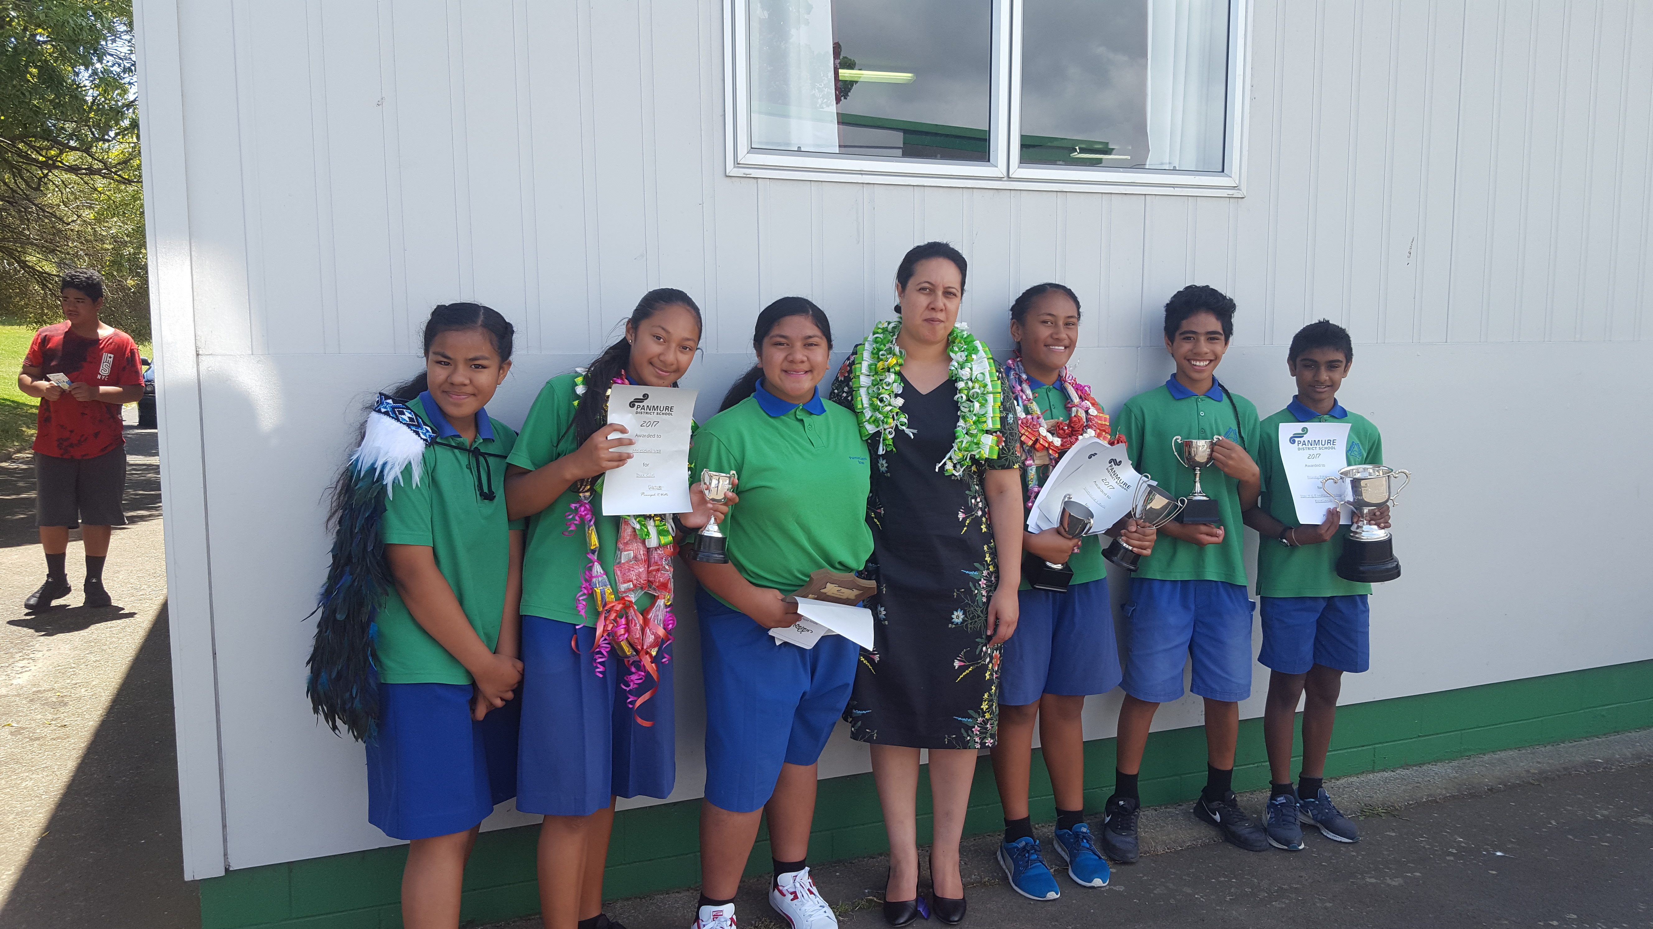

2017 Major Award Winners -
T. L. May Service Award (longest serving principal 1882 – 1913)
  - Bronte Tonga

Cultural
  - Sione Taulanga

Achievement in the face of adversity
  - Leon Wu

Sportsman
  - Anton Ameke

Sportswoman
  - Josephine Lauti

Dux boy
  - Tupara Harrison

Dux girl
  - Meleseini Vea

Overall boy
  - Miracle Vaovasa

Overall girl
  - Josephine Lauti


Winning House for 2017
Congratulations to the winning house – Kowhai

Upcoming Events –
Year 8 Graduation Ceremony - Wednesday 13 December at 6.30pm in the school hall.


Last Day for Term 4 is Thursday 14 December.
School will finish at normal time.

Look Sharp Store Special Notification
"A 10% Discount applies to students, parents and teachers of the school.
To redeem the discount, you must provide the name of your school and the name of the principal. Students wearing school uniform is adequate to get the discount."


Families
Our sincere thanks to you all for your wonderful support and encouragement throughout the year. We do appreciate your contribution, as well as the support and encouragement you give to the students at home with their learning and other school learning activities. Your interest in the school and students’ learning is highly valued.

Our Year 8 Students
To you all, our very best wishes for the future
You all have the ability and with continued determination and personal goal setting will be successful at Secondary School and beyond. Thank you to each one of you.
Good Luck!!!!!

Board of Trustees, Staff, Parents and Students
My grateful thanks for your contribution to a successful year. Have a safe, relaxing holiday – all ready for another successful year in 2018


THANK YOU TO EVERYONE
MERRY CHRISTMAS AND
HAPPY NEW YEAR

